HDOC DAY- 9 ACTIVITY

Question 1
C Program to Find the Remaining Area of a Rectangular Sheet After Removing a Circle

Problem Statement:
Write a C program to find the remaining area of a rectangular sheet when a circle of given radius is removed from it.

Input: Length (l), breadth (b) and radius (r)

Output: Remaining area of the rectangular sheet

Formula:
Area of rectangle= (l*b)
Area of circle= PI*r
Therefore,
Remaining area = (l*b) – (PI*r)
We can take:
PI = 3.14159

Test Case Table:
Test case | Input(l,b,r) | Expected output | Actual output | Result
1 | 10, 8, 2 | 67.43 | 67.43 | Pass
2 | 20, 15, 3 | 221.46 | 221.46 | Pass
3 | 12, 10, 3 | 91.73 | 91.73 | Pass
4 | 15, 12, 4 | 129.73 | 129.73 | Pass
5 | 25, 20, 6 | 386.90 | 386.90 | Pass

Algorithm:
- Start.
- Declare length, breadth, radius, rectangleArea, circleArea and remainingArea.
- Input length, breadth and radius.
- Calculate rectangleArea = length × breadth.
- Calculate circleArea = 3.14159 × radius × radius.
- Calculate remainingArea = rectangleArea - circleArea.
- Display the remaining area.
- Stop.

Algorithm Evaluation:
The algorithm calculates the area of the rectangle and subtracts the area of the removed circle. Therefore, it correctly determines the remaining area.

C Program
C Program
#include <stdio.h>

int main()
{
float length, breadth, radius;
float rectangleArea, circleArea, remainingArea;
const float PI = 3.14159;

printf("Enter length of rectangle: ");
scanf("%f", &length);

printf("Enter breadth of rectangle: ");
scanf("%f", &breadth);

printf("Enter radius of circle: ");
scanf("%f", &radius);

rectangleArea = length * breadth;
circleArea = PI * radius * radius;
remainingArea = rectangleArea - circleArea;

printf("Remaining area = %.2f\n", remainingArea);

return 0;
}

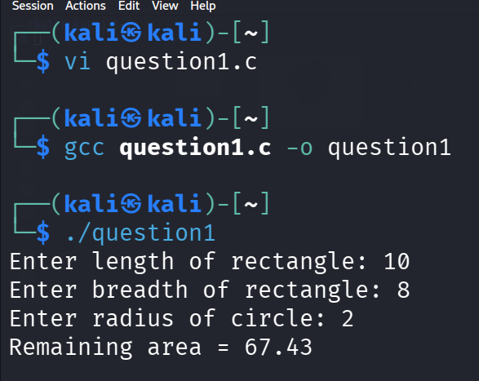
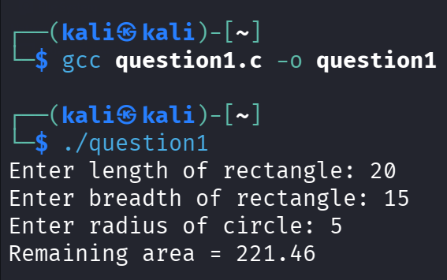
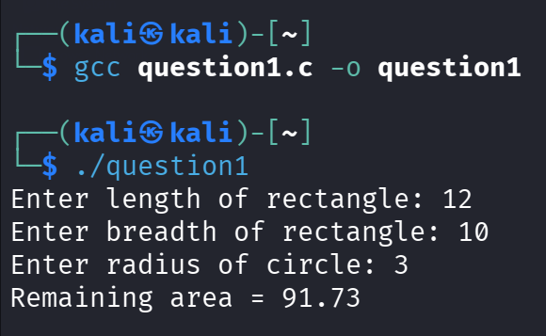
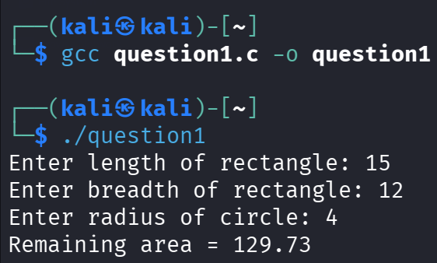
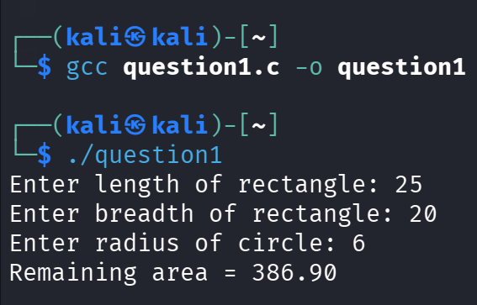

Question 2: Area and Perimeter of a Regular Hexagon

Problem Statement:
Write a C program to find the perimeter and area of a regular hexagon when its side is given.

Input: Side of hexagon (s)

Output: Perimeter and area of the hexagon

Formula:
Perimeter = 6s
Area = 3(root 3)/2 (s)^2

Test Case Table
Test Case | Input | Expected output (perimeter, area) | Actual Output | Result
1 | 2 | 12.00, 10.39 | 12.00, 10.39 | Pass
2 | 4 | 24.00, 41.57 | 24.00, 41.57 | Pass
3 | 5 | 30.00, 64.95 | 30.00, 64.95 | Pass
4 | 6 | 36.00, 93.53 | 36.00, 93.53 | Pass
5 | 10 | 60.00, 259.81 | 60.00, 259.81 | Pass

Algorithm:
- Start.
- Declare side, perimeter and area.
- Input the side of the regular hexagon.
- Calculate perimeter = 6 × side.
- Calculate area = (3 × √3 / 2) × side × side.
- Display the perimeter.
- Display the area.
- Stop.

Alogoritm Evaluation:
The algorithm uses the standard formulas for the perimeter and area of a regular hexagon. Hence, it correctly calculates both required values.

C Program:
#include <stdio.h>
#include <math.h>

int main()
{
float side, perimeter, area;

printf("Enter the side of hexagon: ");
scanf("%f", &side);

perimeter = 6 * side;
area = (3 * sqrt(3) / 2) * side * side;

printf("Perimeter = %.2f\n", perimeter);
printf("Area = %.2f\n", area);

return 0;
}

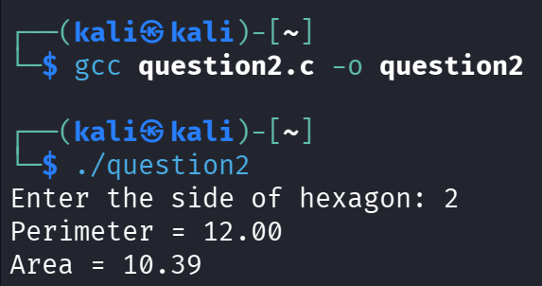
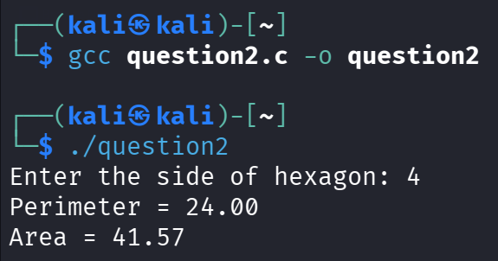
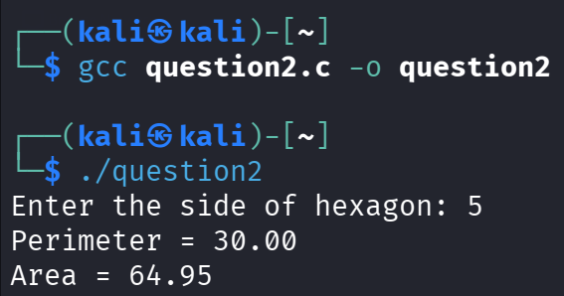
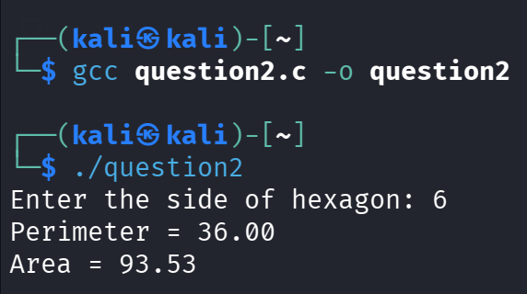
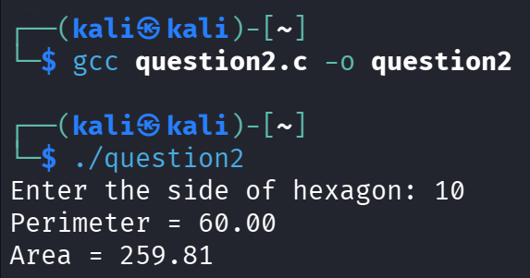

Final Result
Both programs were successfully designed, compiled and tested. The actual outputs obtained from the programs matched the expected outputs for the prepared test cases.
Therefore, both algorithms and C programs were verified successfully and produced correct results.

